

**Western Australian Certificate of Education**

**ATAR course examination, 2018**

**Question/Answer Booklet**

12 PHYSICS

Name

**Test 1 – Projectile Motion**

|  |  |  |  |  |  |  |  |  |  |  |
| --- | --- | --- | --- | --- | --- | --- | --- | --- | --- | --- |
| Student Number: In figures |  |  |  |  |  |  |  |  |  |  |

**Mark: $\frac{}{\text{48}}$**  In words

#### Time allowed for this paper

Reading time before commencing work: five minutes

Working time for paper: sixty minutes

**Materials required/recommended for this paper**

To be provided by the supervisor

This Question/Answer Booklet

Formulae and Data Booklet

***To be provided by the candidate***

Standard items: pens, (blue/black preferred), pencils (including coloured), sharpener, correction fluid/tape, eraser, ruler, highlighters

Special items: non-programmable calculators satisfying the conditions set by the School Curriculum and Standards Authority for this course

**Important note to candidates**

No other items may be taken into the examination room. It is your responsibility to ensure that you do not have any unauthorised notes or other items of a non-personal nature in the examination room. If you have any unauthorised material with you, hand it to the supervisor before reading any further.

**Structure of this paper**

|  |  |  |  |  |  |
| --- | --- | --- | --- | --- | --- |
| Section | Number of questions available | Number of questions to be answered | Suggested working time  (minutes) | Marks available | Percentage of exam |
| Section One:  Short Answers | - | - | - | - | - |
| Section Two:  Problem-solving | 10 | 10 | 60 | 50 | 100 |
| Section Three:  Comprehension | - | - | - | - | - |
|  |  |  |  | **Total** | 100 |

**Instructions to candidates**

1. The rules for the conduct of examinations at Holy Cross College are detailed in the College Examination Policy*.* Sitting this examination implies that you agree to abide by these rules.

2. Write your answers in this Question/Answer Booklet.

3. Working or reasoning should be clearly shown when calculating or estimating answers.

4. You must be careful to confine your responses to the specific questions asked and to follow any instructions that are specific to a particular question.

5. Spare pages are included at the end of this booklet. They can be used for planning your

responses and/or as additional space if required to continue an answer.

• Planning: If you use the spare pages for planning, indicate this clearly at the top of the page.

• Continuing an answer: If you need to use the space to continue an answer, indicate in the original answer space where the answer is continued, i.e. give the page number. Fill in the number of the question(is) that you are continuing to answer at the top of the page.

6. Answers to questions involving calculations should be ***evaluated and given in decimal***

***form*.** It is suggested that you quote all answers to ***three significant figures***, with the

exception of questions for which estimates are required. Despite an incorrect final result, credit may be obtained for method and working, providing these are ***clearly and legibly set out***.

7. Questions containing the instruction "estimate" may give insufficient numerical data for their solution. Students should provide appropriate figures to enable an approximate solution to be obtained. Give final answers to a maximum of two significant figures and include appropriate units where applicable.

8. Note that when an answer is a vector quantity, it must be given with magnitude and direction.

9. In all calculations, units must be consistent throughout your working.

1. Answer the following questions about when a projectile is launched horizontally in air. (Disregard air resistance.) [3 marks]

(a) Which component of its velocity remains constant?

(b) Which component changes uniformly with time?

(c) If the initial horizontal velocity of the projectile is decreased, will the time taken for the projectile to fall to the ground be decreased, increased or remain the same?

2. An archer fires an arrow from point A and hits target E as shown in the diagram. Points B and D are at the same height. Point C is the highest point of the flight. Assume no air resistance is acting.

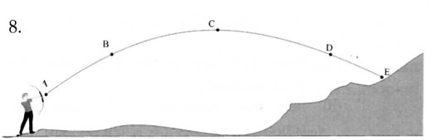

(a) At which point has the arrow got the greatest vertical velocity? [1 mark]

(b) Draw arrows to show the direction of the acceleration experienced by points B and C. [2 marks]

(c) At which point(s) (if any) is the velocity zero? [2 marks]

(d) At points B and D, which of the following (if any) would have equal values?

**(Circle your choices.)**

(i) velocity (ii) speed (iii) acceleration [2 marks]

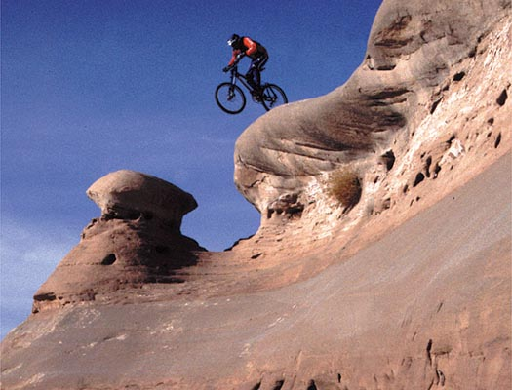3. During a particularly arduous downhill section in a mountain bike race, competitors had to ride horizontally off a rocky ledge before landing on a flat section on the side of a large hill.

speed = 4.50 ms-1

height = 3.50 m

A competitor moving at 4.50 ms-1 leaves the ramp and lands 3.50 m below on level ground.

(a) How long does it take to reach the ground? [3 marks]

(b) How far horizontally does he land from the base of the ramp? [2 marks]

4. A golfer practising on the local driving range hits a ball at 45.0 ms-1 at an angle of 20.0° from the first floor of the complex, which is 6.00 m above the landing point of the ball. Assume no air resistance.

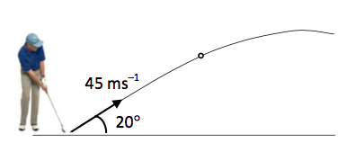

6.00 m

(a) Determine how long it takes for the ball to reach the landing point on the fairway. [3 marks]

(b) What is the maximum height reached by the ball above the fairway? [3 marks]

(c) Calculate the horizontal range of the ball. [3 marks]

(d) What is the impact velocity of the ball on the fairway? [4 marks]

5. In a stunt car record attempt, a car is driven off a ramp at 1.40 x 102 kmh-1 at an angle of 20.0°. A similar ramp is placed on the other side for the car to land on. Assume the car lands at the same height as the take off point.

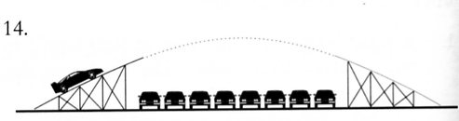

(a) Calculate how far apart the ramps must be for the car to just land safely on the second ramp. [5 marks]

(b) In reality, the organisers know that the answer to part (a) is theoretical and that they must plan to have a "safety margin" to ensure the car lands safely.

Explain what would be the "real" distance covered and why this is the case.

[2 marks]

6. A firefighter 50.0 m away from a burning building directs a stream of water from a fire hose at an angle of 30.0° above the horizontal as shown below. If the velocity of the stream is

40.0 ms-1, at what height will the water strike the building?

(Assume the water leaves the hose at ground level and stays together as a stream until it hits the building.) [5 marks]

